DEPARTMENT DATA ANALYSIS

A PROJECT REPORT

Submitted by
Alisha Gakhar (21BCS3850)
Raghav Deshwal (21BCS11849)
in partial fulfillment for the award of the degree of

BACHELOR OF ENGINEERING
IN

COMPUTER SCIENCE ENGINEERING (BIG DATA AND ANALYTICS)


Chandigarh University

FEBRUARY 2023

BONAFIDE CERTIFICATE

Certified that this project report “DEPARTMENT DATA ANALYSIS” is the bonafide work of “ALISHA GAKHAR, RAGHAV DESHWAL” who carried out the project work under my/our supervision.

SIGNATURE SIGNATURE

SUPERVISOR HEAD OF THE DEPARTMENT

<<Academic Designation>>

<<Department>> <<Department>>

Submitted for the project viva-voce examination held on __________________

INTERNAL EXAMINER EXTERNAL EXAMINER

Table of Contents Page No.
List of Figures
Abstract 1
Chapter 1. Introduction 2
Chapter 2. Literature Survey 3
Chapter 3. Design/Flow Process 7
Chapter 4. Results Analysis and Validation 8
Chapter 5. Conclusion and Future Scope 10
References 11

List of Figures Page no.
Figure1. Student-Data flow diagram 3
Figure2. Overall Block Diagram 4
Figure3. Dashboard (Result) 8
Figure4. Interactive Dashboard 9

ABSTRACT
The effective analysis of data is crucial for informed decision-making in any department. To develop a robust system for departmental data analysis, it is necessary to follow a structured approach. This abstract outline the steps to be taken for proposing a new system for departmental data analysis. The first step is to define the goals and objectives of the data analysis system, including the type of data to be collected and the insights expected from it. Next, identifying the data sources is critical, including both internal and external sources. Choosing a suitable data analysis tool, such as a software package or custom-built solution, is essential for efficient analysis of the data. Developing a data analysis process that is flexible and adaptable is the next step, which should guide data collection, cleaning, analysis, and reporting. Setting up a data governance framework is crucial to ensure data integrity and security, including who can access the data, how it can be used, and how it will be protected. Finally, providing adequate training and support to staff who will be using the data analysis system is essential for optimal utilization of its capabilities. By following these steps, a department can develop an effective and reliable system for data analysis, enabling them to make informed decisions and gain valuable insights from the collected data. Other than the above steps, we can use Tableau to analyse and work on the departmental data and may computerize traditional method of taking attendance and analysing the absence and notices and circulars, etc.
Keywords— Data analysis, decision-making, internal sources, external sources, data analysis tool, data collection, data cleaning, data reporting, data integrity, departmental data analysis, tableau

Chapter 1
INTRODUCTION
Many organizations have large amounts of departmental data that could be used to inform decision-making and drive business growth. However, analysing and interpreting this data can be complex and time-consuming task, especially when dealing with multiple departments within an organization. The lack of an efficient data analysis process can lead to misleading opportunities, ineffective decision making, and ultimately, a decrease in productivity and revenue. Therefore, the problem statement is how to develop an efficient and effective departmental data analysis process that enables organizations to leverage their data to make informed decisions, improve performance, and achieve their analysis goals. This process should consider the various data sources, the complexity of the data, and the different departmental needs while also ensuring data accuracy, consistency, and privacy.

Chapter 2
LITERATURE SURVEY
An easy way to comply with the conference paper formatting requirements is to use this document as a template and simply type your text into it.
- EXISTING SYSTEM
There are many existing systems for departmental data analysis that works on Android/web. They have many features including registrations/logins-logouts. The complexity of these systems makes it difficult to work on them and simply perform analytical operations using them. Some of them are:
• Information management system for managing student attendance online: It included features like Prevent Time Theft, Increase Productivity, and Improve Efficiency. The database, object-oriented programming, and networking methodologies form the foundation of UTB-SAMIS. The front-end software for this system is PHP, an object-oriented programming language with connectivity to MySQL, the back-end software, and a few cutting-edge client-side technologies. The student-side DFD of this system is shown in the given figure:

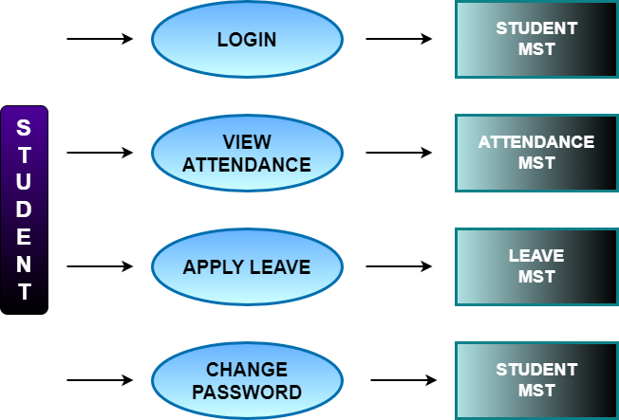

Figure1. Student-Data flow Diagram

• Attendance Management System: It used an Android app, a database, GUI, and an API with Microsoft SQL as a query language and ASP.NET framework for the backend as it is capable of handling web applications, dynamic websites, and mobile applications effectively. In this system, users are categorized as nonmanagerial employees, Managers, and HR admin. The checking and check-out time of employees are tracked using fingerprint scanners and that data is used in the proposed system. Mainly using that data working hours of the employees are calculated. This proposed system allows each employee to view his/her attendance for a desired time period. As well Managers and HR admin can view the attendance of all employees. By analysing theses data reports are generated. Other than that, employees are allowed to apply leaves using this system. Here leaves are categorized and employees can view their leave balance in each category.

• Fingerprint-based attendance system using an Arduino board: The attendance module, report module, fingerprint module, schedule module, lecturer module, and student module are the main modules of the fingerprint attendance system. Figure 1 depicts the designed block diagram in the portable attendance system. In the hardware implementation, Arduino Mega was attached to the SD card, and the Fingerprint scanner. As for the software, the code was compiled using the Arduino compiler IDE.

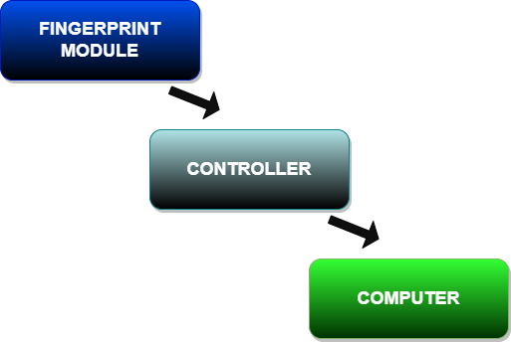

Figure2. Overall Block Diagram

• Attendance Management System from Islamic University of Technology (IUT): This system had concrete functionalities, Efficiency and accuracy, framework, web services, availability of both computer and android version. This attendance management system was created with the intention of computerising the conventional method of taking attendance. The software's automatic report generation at the end of the semester is another reason for its development.

- PROPOSED SYSTEM
The Departmental Data Analysis System is a software tool that enables the collection, analysis, and reporting of data from various sources to support informed decision-making within an organization. With the help of this system, company operations may be enhanced, resource allocation can be optimized, and overall performance can be improved. This analysis project will introduce management software to digitize departmental data management, which now requires manual, paper-based procedures. Users of the software will also receive analysis attendance reports with varying levels of access (for instance, faculties can examine all student attendance reports). The program will maintain a record of the departmental divisions' timetables. Additionally, the software will offer an E-Noticeboard service that will be used to distribute announcements to department members. The instructors will be able to initiate a communication session with students using the program.
Data Sources:
The data sources for the Departmental Data Analysis System may include:
• University datasets
• School datasets
• Dummy datasets

Data Analysis Tool: The Departmental Data Analysis System will utilize a data analysis tool to analyze and visualize data effectively. The chosen tool should be user-friendly, scalable, and able to integrate with various data sources. Here, we may be using Tableau for analysing purpose on this data.

Data Analysis Process: The Departmental Data Analysis System will follow a normally defined data analysis process that includes:
• Data collection and cleansing
• Data analysis and modelling
• Data visualization and reporting
• Ongoing monitoring and optimization.

Data Governance Framework: To ensure the security and integrity of the data, a data governance framework may or may not be established. This framework might define:
• Access control policies
• Data storage and encryption standards
• Data usage guidelines
• Data backup and recovery procedures

Training and Support: The Departmental Data Analysis System may or may not provide training and support to users to ensure they can effectively use the system. This might include:
• User manuals and documentation
• Training sessions and workshops
• Technical support for system issues

Chapter 3
DESIGN FLOW/PROCESS
A general methodology for conducting departmental data analysis:
- Define the objective: Start by identifying the objective of the analysis. Ask yourself what problem you are trying to solve or what question you are trying to answer. This will help you stay focused throughout the analysis.
- Identify the data sources: Next, identify the data sources that you will need to collect or access. This may include internal databases, external sources, or surveys that need to be conducted.
- Collect the data: Once you have identified the data sources, collect the data needed for the analysis. This may involve cleaning and transforming the data, such as removing duplicates or missing values.
- Analyze the data: Use statistical techniques, charts, and other tools to analyze the data. You may want to segment the data by different categories, such as time periods, customer segments, or products.
- Interpret the results: Once you have analyzed the data, interpret the results to draw conclusions and make recommendations. This may involve identifying trends, patterns, or relationships in the data.
- Communicate the findings: Finally, communicate the findings to stakeholders in a clear and concise manner. This may include creating visualizations or reports that highlight the key insights and recommendations.
- Take Action: After communicating the findings, take action based on the insights and recommendations. This can entail putting new plans into action or altering current procedures. Monitor the results of these actions and continue to iterate and improve the analysis as needed.

Chapter 4
RESULTS ANALYSIS AND VALIDATION
The proposed system for departmental data analysis will provide the following results: A clear definition of goals and objectives for the data analysis system, which will help align business goals with data analysis efforts. Identification of various data sources that can provide valuable insights for decision-making. Selection of an appropriate data analysis tool that can effectively analyse and visualize the collected data. Development of a data analysis process that can be adapted to changing needs and requirements, enabling continuous improvement. Establishment of a data governance framework that ensures the security and integrity of the data, which is essential for compliance and risk management. Training and support for staff who will be using the data analysis system, ensuring that they can effectively use the system to make informed decisions. Overall, the proposed system will enable better decision-making by providing valuable insights that can help improve business processes, optimize resource allocation, and enhance overall performance. This can lead to increased efficiency, productivity, and profitability for the organization.
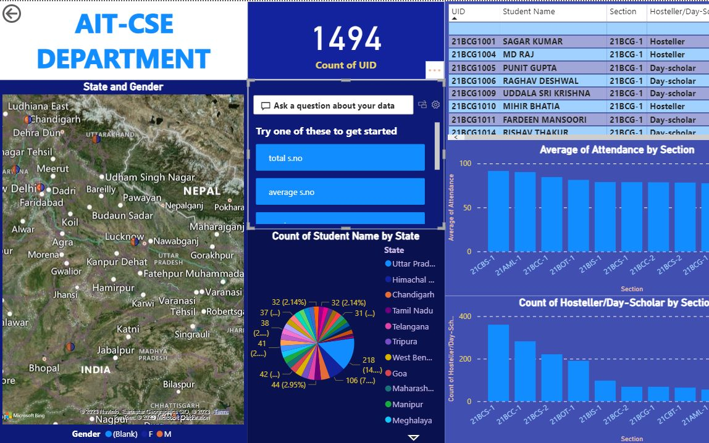
Figure3. Dashboard (Result)
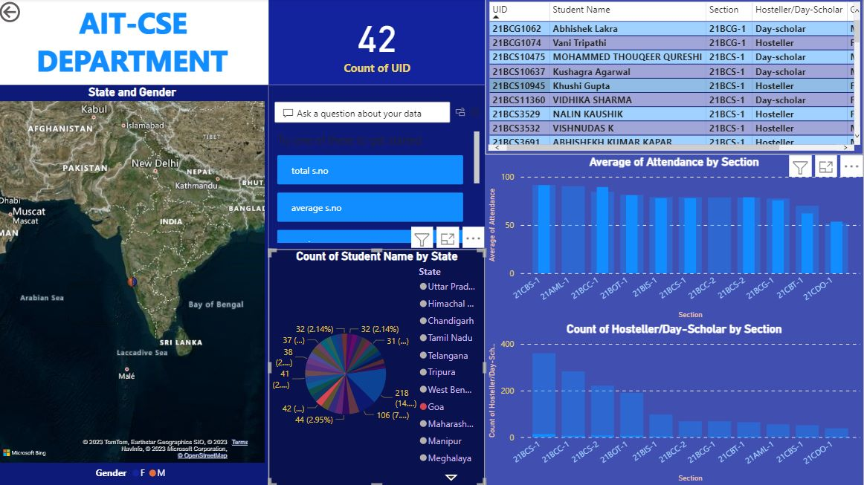
Figure4. Interactive Dashboard

Chapter 5
CONCLUSION AND FUTURE WORK
The departmental Data Analysis System is designed to support informed decision-making by providing valuable insights from various data sources. By following a defined data analysis process and implementing a data governance framework, this system can ensure the security and integrity of the data while providing accurate and timely information to support business goals.
We propose a departmental data analysis system that may or may not have one or more of the following features-
  - Attendance Management System,
  - Notices and information,
  - Circulars and related data,
  - Analysis of the departmental data,
  - Tableau Dashboard.

Moreover, to preserve the traditional attendance system– We may also work on the traditional attendance methods and prepare a separate analysis for spam/fake/proxy attendance. The analysis may not only ensure that the attendance is safe but may also specify whether there is spam/proxy or not.

REFERENCES

- GATETE Marcel, HARUBWIRA Flaubert, “A Development of an Online Student Attendance Management Information System: Case Study “University of Tourism, Technology, and Business Studies”,” International Journal of Scientific Research in Computer Science and Engineering, Vol.10, Issue.1, pp.32-48, 2022.

- K.J.H.D. Asiri, K.S. Rishan, U.A. Hewage., U.K.T. Prasadika, K.A. Dilini T. Kulawansa “ Attendance Management System”,” 8th International Conference on Advances in Computing, Electronics and Communication – ACEC”M. Wegmuller, J. P. von der Weid, P. Oberson, and N. Gisin, “High resolution fiber distributed measurements with coherent OFDR,” in Proc. ECOC’00, 2000, paper 11.3.4, p. 109.

- Ekhlas Ghaleb Abdulkadhim 2021 J. Phys.: Conf. Ser. 1804 012011(2002) The IEEE website. [Online]. Available: http://www.ieee.org/.

- Abdoulrahmaine Mohammad, Mohammad Elmi Hassan, Muslim Musa -2020, “IUT DHAKA 123456789/92”.

- Mrs Dhanashree Amit Gupta “ Student Attendance Software”,” IJSER VOLUME 2, ISSUE 11, NOVEMBER 2011”.

- S. Y. Inamdar1, Vishal V. Suryawanshi2 “Student Attendance System based on Data Analytics“, “IARJSET VOL. 4, Special Issue 4, January 2017”.

- Zhang, L., Stoffel, A., Behrisch, M., Mittelstadt, S., Schreck, T., Pompl, R., Weber, S., Last, H., Keim, D. “Visual Analytics for the Big Data Era—A Comparative Review of State-of-the-Art Commercial Systems.”, “IEEE Conference on Visual Analytics Science and Technology (VAST), pp. 173–182 (2012)”

- Jinkyu Lee and Ivan Tashev, “High-level feature representation
using recurrent neural network for speech emotion recognition,” 2015.

- Kun Han, Dong Yu, and Ivan Tashev, “Speech emotion recognition using deep neural network and extreme learning machine,” in Fifteenth annual conference of the international speech communication association, 2014.

- Vladimir Chernykh, Grigoriy Sterling, and Pavel Prihodko, “Emotion recognition from speech with recurrent neural networks,” “arXiv preprint arXiv:1701.08071, 2017”

- Marra, G., & Wood, S. N. “Practical variable selection for generalized linear models with spatially correlated errors. “Journal of the Royal Statistical Society: Series B (Statistical Methodology), 73(3), 389-417. (2011)”

- Lee, S., & Yoon, H. J. “Analysis of factors affecting department performance in higher education institutions.”, “Journal of Educational Administration and Policy Studies, 10(3), 80-88. (2018)”

- Chen, Y. Y., & Chen, M. Y. “Analyzing and improving the quality of patient care in a department of radiology using statistical process control charts.”, “Journal of Medical Imaging and Radiation Sciences, 50(1), 132-139. (2019)”

- Zhang, X., & Wang, Y. “Analysis and prediction of department sales data using artificial neural networks.”, “Journal of Computer Science and Technology, 35(4), 763-772(2020).”

- Kim, H. J., & Kim, D. H. “Analysis of factors affecting employee turnover in a department store: a case study.”, “Journal of Distribution Science, 17(3), 41-48(2019).”

- Chen, C. C., & Liu, Y. Y. “Analysis of service quality in a department store using a hybrid fuzzy MCDM model.”, “International Journal of Applied Decision Sciences, 12(1), 28-46(2019).”

- Jia, Y., & Tang, Y. “Analysis of the factors influencing the competitiveness of a department store based on the diamond model.” “Journal of Business Research, 116, 165-174(2020).”

- Song, D., Yang, X., & Cai, Y. “Analysis of the impact of environmental factors on employee productivity in a department of a manufacturing company.”, “Journal of Cleaner Production, 249, 119270. (2020).”

- Tan, Z., & Chen, J. “Analysis of the factors affecting employee job satisfaction in a department of a hospitality company: a case study.”, “Journal of Hospitality and Tourism Management, 46, 202-212. (2021)”

- Keshavarz, R., Goli, A., & Mardani, A. “Analysis of supply chain disruptions in a department of a manufacturing company using fuzzy TOPSIS method.”, “International Journal of Production Research, 57(3), 763-779. (2019).”

- Lee, J. H., & Kim, M. H. “Analysis of employee engagement and its impact on department performance in a financial company.”, “Journal of Open Innovation: Technology, Market, and Complexity, 6(3), 54. (2020)”

- Xue, L., Liu, J., & Lu, Q. (2021). “Analysis of the impact of environmental factors on customer satisfaction in a department store using a Bayesian network.”, “Journal of Retailing and Consumer Services, 63, 102702.”

- Luo, Y., Wang, J., & Fan, X. (2018). “Analysis of departmental performance in a public hospital using data envelopment analysis.” “BMC Health Services Research, 18(1), 521.”

